Washington State Legislature
Legislative Building

Olympia, WA 98504-0600

April 15, 2020

The Honorable Jay Inslee
Governor
State of Washington
Legislative Building
Olympia WA 98504

Dear Governor Inslee:

We are in receipt of your letter dated April 10, 2020 requesting extension of the statutory waivers and suspensions ordered in Proclamations 20-15, 20-20, 20-21, 20-23, and 20-23.1, in response to the ongoing COVID-19 State of Emergency.

We agree that strict compliance with the specific statutory obligations and limitations cited in these proclamations would prevent, hinder, or delay action that is necessary in coping with the COVID-19 State of Emergency.

Pursuant to RCW 43.06.220(4), we hereby extend the statutory waivers and suspensions cited in these proclamations until the termination of the COVID-19 State of Emergency or May 4, 2020, whichever occurs first.

Sincerely,

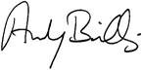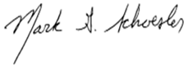

ANDY BILLIG MARK SCHOESLER
Senate Majority Leader Senate Minority Leader

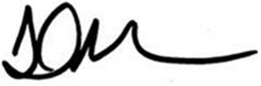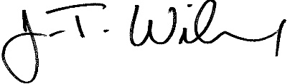
LAURIE JINKINS J.T. WILCOX
Speaker of the House House Minority Leader

